**Electronic Supporting Information**

Identification of the Elusive Methyl-Loss Channel in the Crossed Molecular Beam Study of Gas Phase Reaction of Dicarbon Molecules (C2; X1/a3Πu) with 2-Methyl-1,3-butadiene (C5H8; X1A′)

*Iakov A. Medvedkov,1 Zhenghai Yang,1 Shane J. Goettl,1 Ralf I. Kaiser1\**

1 Department of Chemistry, University of Hawai‘i at Manoa, Honolulu, HI 96822, USA

*Corresponding to: ralfk@hawaii.edu

Contents

1. Center-of-mass translational energy P(ET), (b) angular T(θ) flux distributions, for the atomic chlorine loss channel in the reaction of the chloroethynyl radical (C2Cl) with 2-methyl-1,3-butadiene (C5H8). S2

2. Center-of-mass translational energy P(ET), (b) angular T(θ) flux distributions, for the atomic hydrogen loss channel in the reaction of dicarbon C2 with 2-methyl-1,3-butadiene (C5H8). S3

# Center-of-mass translational energy P(ET), (b) angular T(θ) flux distributions, for the atomic chlorine loss channel in the reaction of the chloroethynyl radical (C2Cl) with 2-methyl-1,3-butadiene (C5H8).

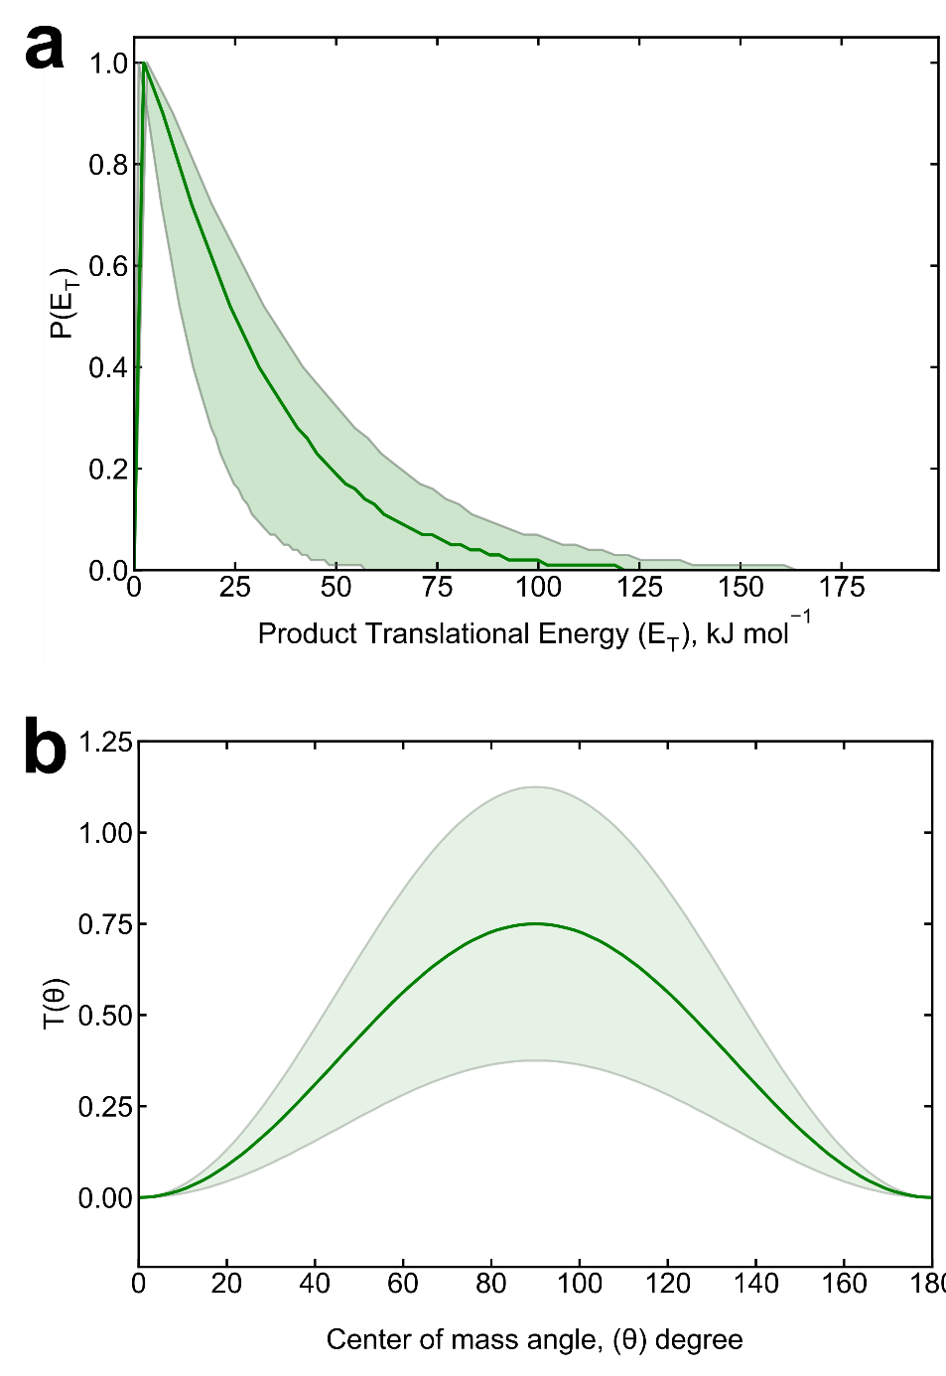

**Figure S1.** (a) Center-of-mass translational energy P(ET), (b) angular T(θ) flux distributions, for the reaction of the chloroethynyl radical with 2-methyl-1,3-butadiene. The solid lines represent the best fit, while the shaded areas indicate the error limits

# Center-of-mass translational energy P(ET), (b) angular T(θ) flux distributions, for the atomic hydrogen loss channel in the reaction of dicarbon C2 with 2-methyl-1,3-butadiene (C5H8).

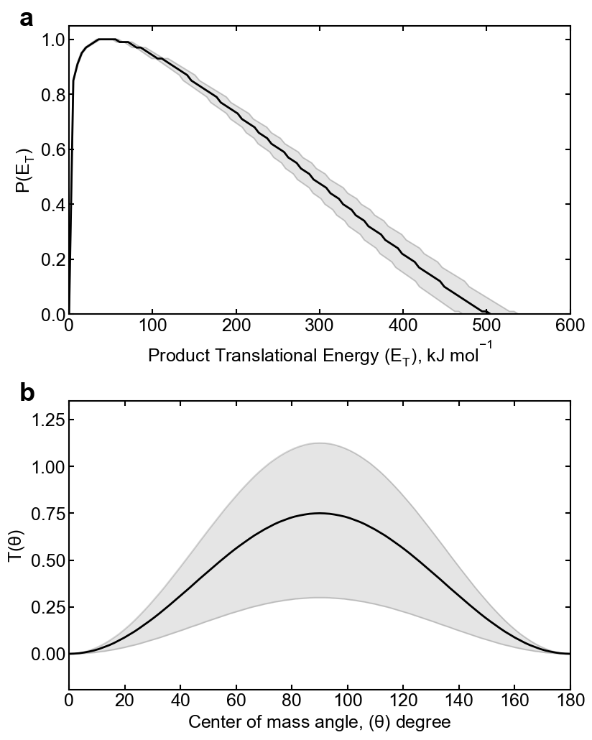

**Figure S2.** (a) Center-of-mass translational energy P(ET), (b) angular T(θ) flux distributions, for the atomic hydrogen loss channel in the reaction of dicarbon with 2-methyl-1,3-butadiene. The solid lines represent the best fit, while the shaded areas indicate the error limits